**Model Development Phase Template**

|  |  |
| --- | --- |
| Date | 15 March 2024 |
| Team ID | LTVIP2024TMID24955 |
| Project Title | SMS Spam Detection - AIML |
| Maximum Marks | 4 Marks |

**Initial Model Training Code, Model Validation and Evaluation Report**

The initial model training code will be showcased in the future through a screenshot. The model validation and evaluation report will include classification reports, accuracy, and confusion matrices for multiple models, presented through respective screenshots.

**Initial Model Training Code:**

Paste the screenshot of the model training code

**Model Validation and Evaluation Report:**

|  |  |  |  |
| --- | --- | --- | --- |
| **Model** | **Classification Report** | **Accuracy** | **Confusion Matrix** |
| Multinomial Naive Bayes | Screenshot of the classification report | 0.9681 | Screenshot of the confusion matrix |
| SVC(sigmoid) | Screenshot of the classification report | 0.9652 | Screenshot of the confusion matrix |
| SVC(rbf) |  | 0.9623 | … |
| Decision Tree Classifier |  | 0.9497 |  |

**MODEL -- SVC(rbf) ** ACCURACY -- [0.9623]**

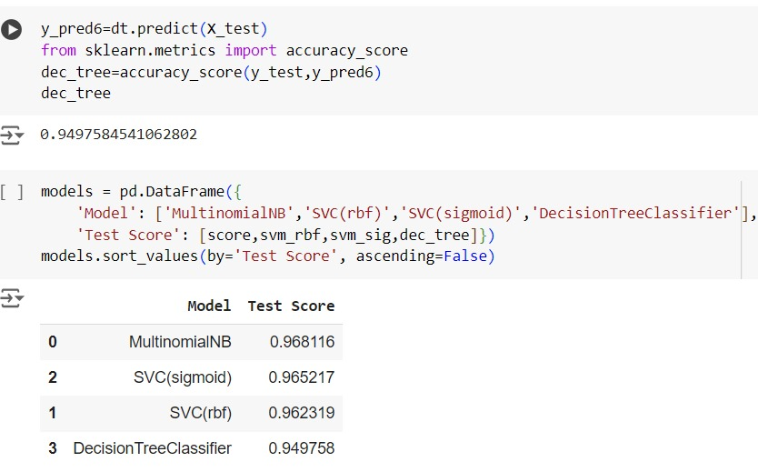

**MODEL – Decision tree classifier ** ACCURACY – [0.9497]**

